Components on the project:

1. RestaurantFinder\Server.js – Initialize server and start the service
2. RestaurantFinder\Routes\Restaurant.js – Rest API
3. RestaurantFinder\Dbaccess\db.js – Db Access layer
4. RestaurantFinder\client – Angular UI
   1. App.component – The main component which loads other components
   2. Components\restaurant\restaurant.component – Restaurant component
   3. Services\RestaurantService – Service layer that interacts with API
5. RestaurantFinder\client\\*spec.js – Unit test cases for UI
6. RestaurantFinder\test\

Steps to Run Project:

1. ~\RestaurantFinder> npm install
2. ~\RestaurantFinder\client> npm install
3. ~\RestaurantFinder> node server (or nodemon server)
4. ~\RestaurantFinder\client> npm start (only needed when there changes in UI layer)

Unit Tests:

1. ~\RestaurantFinder>mocha test
2. ~\RestaurantFinder\client>npm test

Work Progress screenshots:

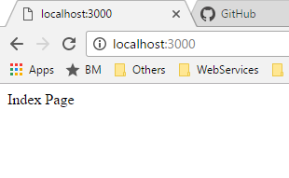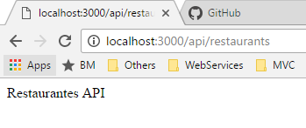

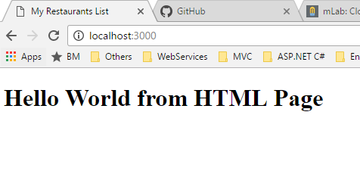

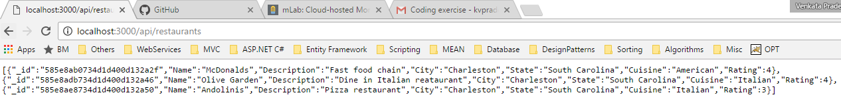

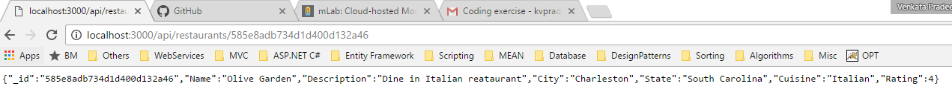

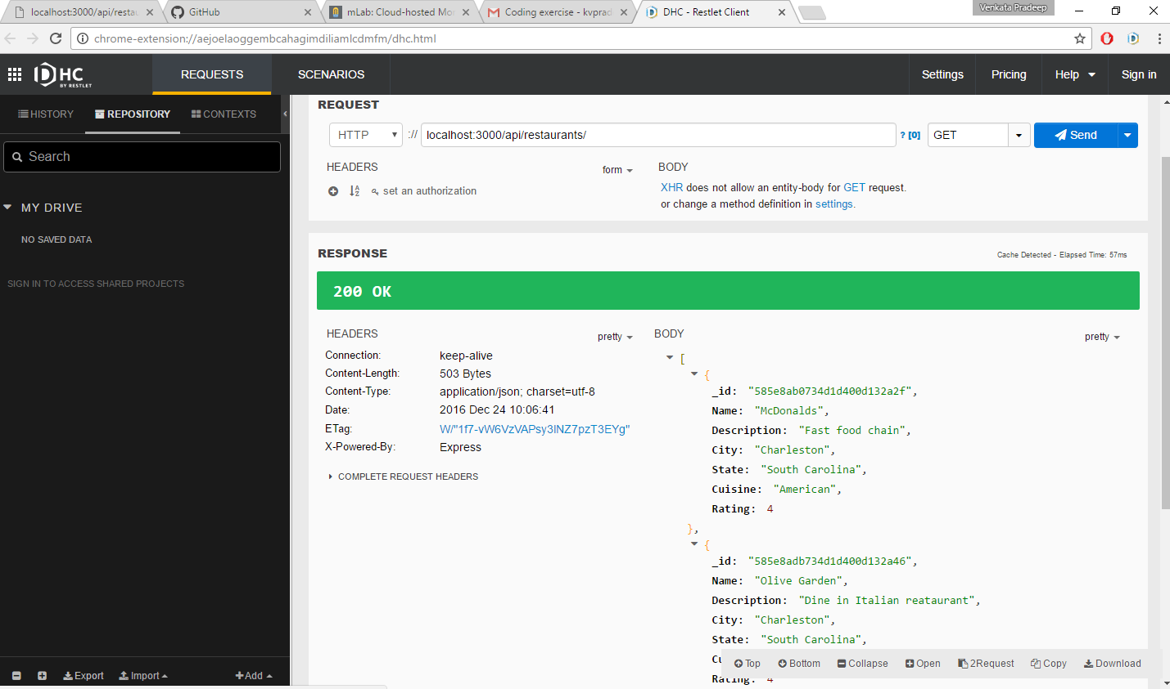

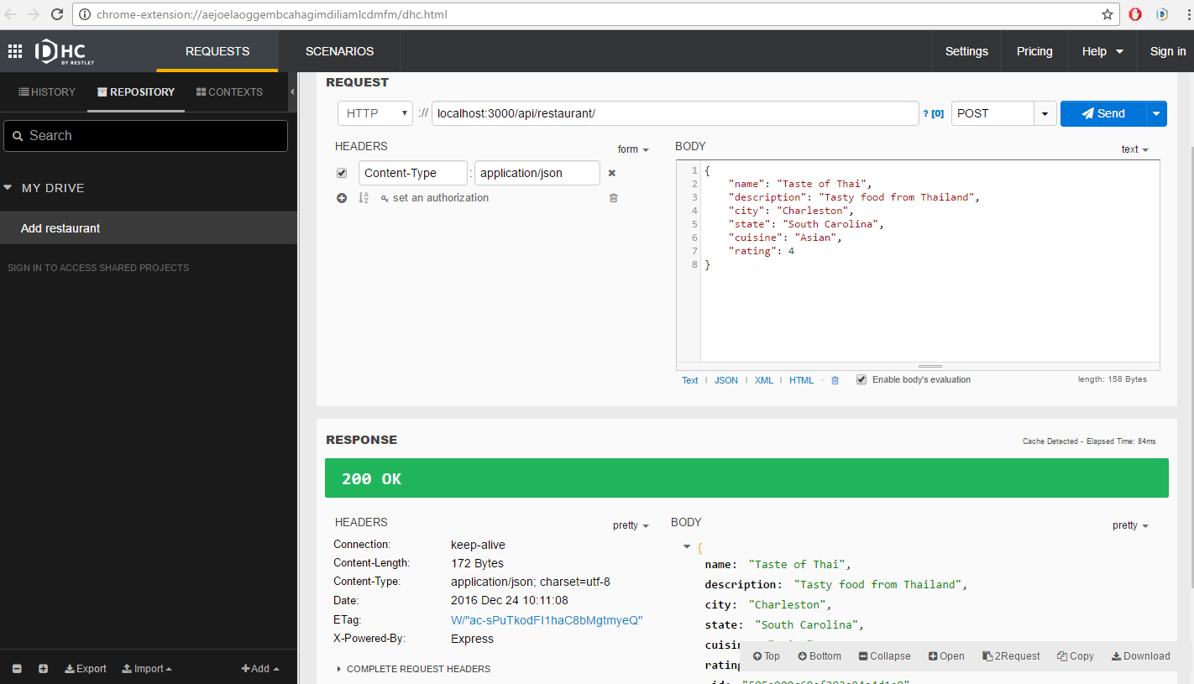

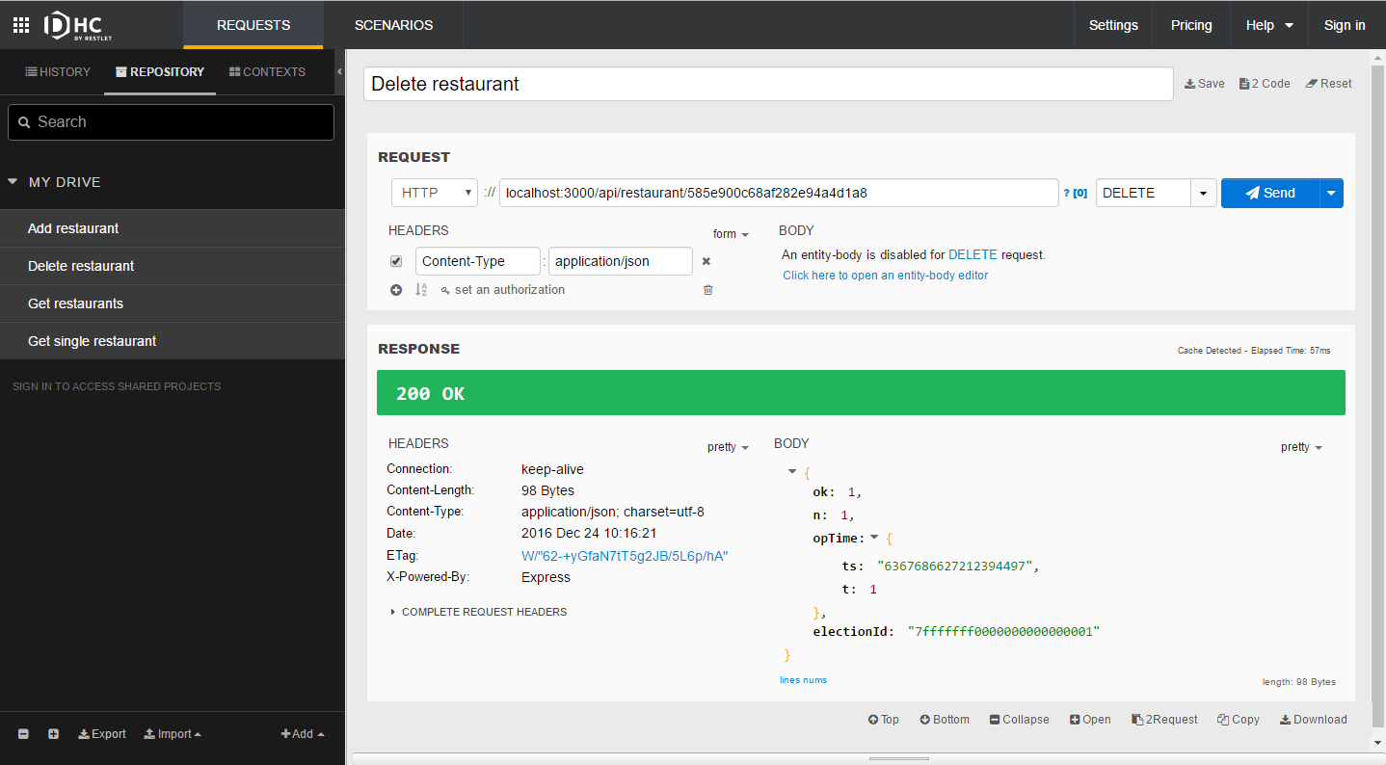

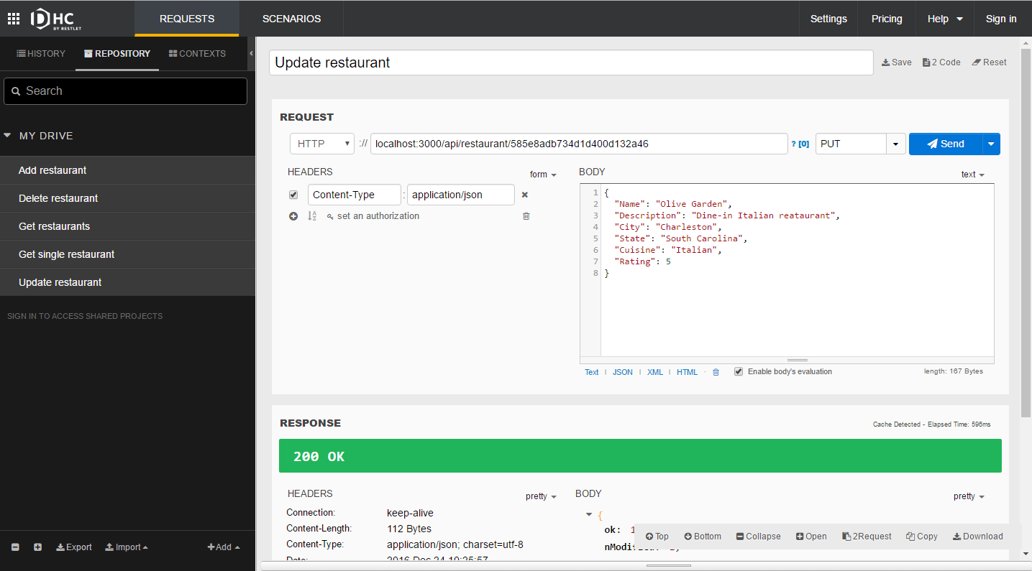

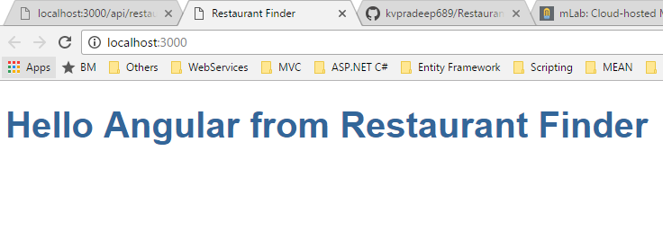

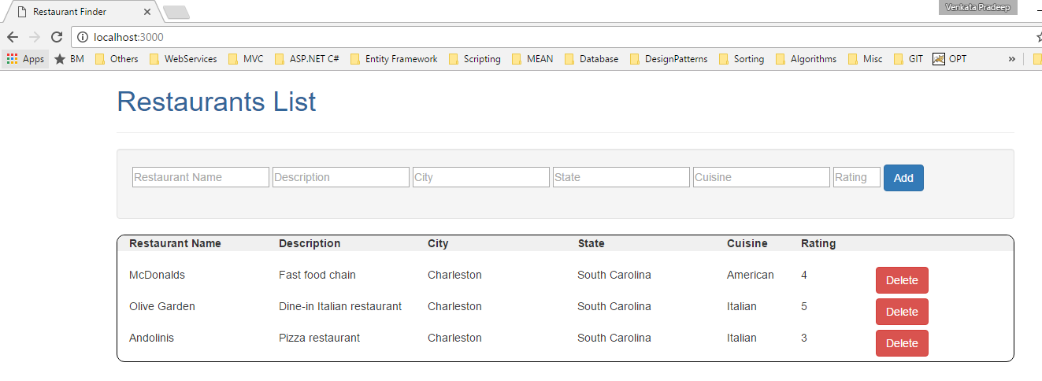

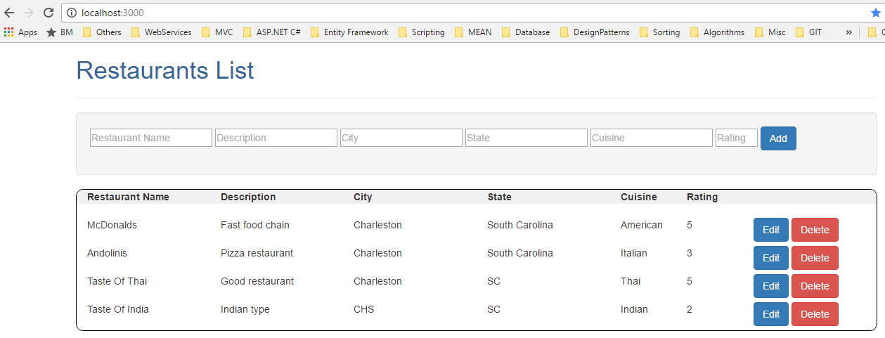

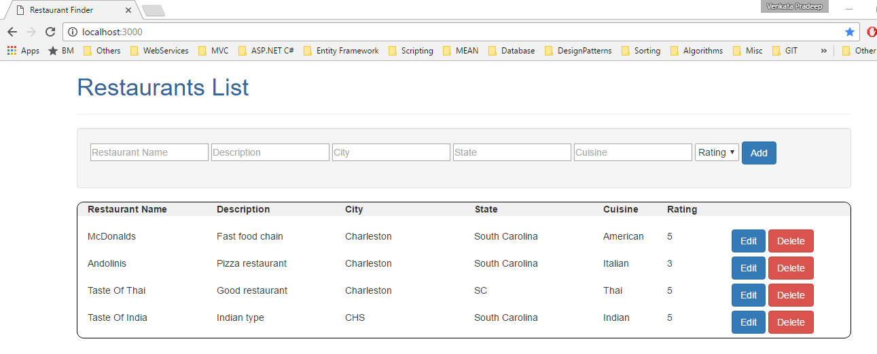

Unit Test Cases:

